CSS Box Model

Theory Assignment
Question 1: Explain the CSS box model and its components (content, padding, border, margin). How does each affect the size of an element?
Ans: The box model describes how space is calculated around and inside elements — including content, padding, border, and margin.

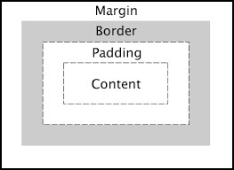

- Content:
    - This is where your text, image, or other content lives.
    - It’s the innermost part of the box.
    - You can set it’s width/height using width and height.

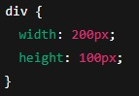

- Padding:
    - This is the space between the content and the border.
    - It adds internal spacing inside the block.
    - Increase the overall size of the element.

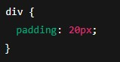

- Border:
    - This is the line around the padding and the content.
    - You can control it’s thickness, style, and color.

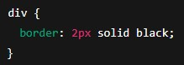

- Margin:
    - This is the space outside the element – it separates the element from others.
    - Doesn’t add to the element’s size, but adds space around it.
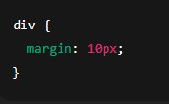
How it affects the total size:
By default, total element size = width + padding + border + margin

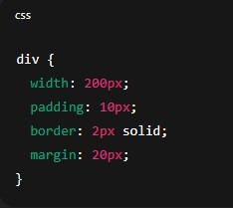

Total width:
= 200 (content) + 102 (padding) + 22 (border) = 224px
Margin is outside this, so extra 20*2 = 40px spacing around the element.

Question 2: What is the difference between border-box and content-box box-sizing in CSS? Which is the default?

Ans: The primary difference lies in how a browser calculates the total width and height of an element. In content-box, the width and height properties apply only to the content area, whereas in border-box, they include the padding and border as well.

Property | content-box (Default) | border-box
Total Width Formula | width + padding + border | width (includes padding & border)
Total Height Formula | height + padding + border | height (includes padding & border)
Layout Behaviour | Adding padding or borders makes the element larger. | The content area shrinks to accommodate padding and borders.
Common Use Case | Default browser behaviour. | Standard practice for modern, predictable layouts.

Key Concepts
content-box: This is the default value. If you set an element to 200px wide with 20px padding and a 5px border, the actual rendered width will be 250px (200 + 20 + 20 + 5 + 5).
border-box: Often preferred by developers because it makes sizing more intuitive. If you set an element to 200px wide, it will always be 200px wide, regardless of how much padding or border you add.

Many developers use a "CSS Reset" to apply box-sizing: border-box to all elements. This prevents layout breaking when adding borders or padding to elements with percentage-based widths (like four 25% boxes not fitting in one row).

- The main difference between border-box and content-box in CSS:
- Content-box:
- Only the content is included in the width/height you set.
- Padding and border are added outside the defined size.
- 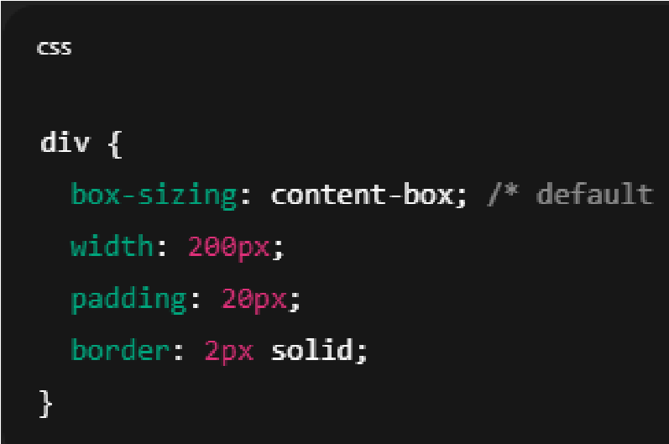
- Total width = 200 + 40 (padding) + 4 (border) = 244px
- Border-Box:
- The padding and border are included inside the width/height.
- The content shrinks to make room for padding and border.
- 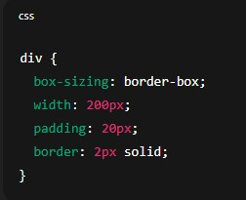
- Total width = 200px, not more — browser adjusts the content area to fit.
- The default value of box-sizing is border-box.

